10 FREE LEARNING WEBSITES FOR KIDS
https://fbcdn-sphonos-e-a.akamaihd.net/

www.switcherroozoo.com

www.starfall.com

www.reading.ecb.org

www.seussville.com

www.abcya.com

www.funbrain.com

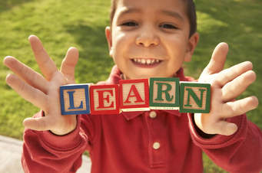
Dear Family, here´s a list of some fun, educational, and safe web sites for your kids…see you soon.

