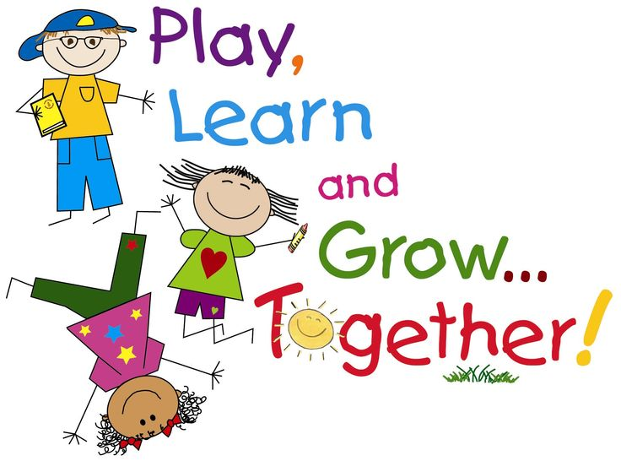
English reassessment test
Objective: to acquire basic vocabulary and simple structure those enable them to express in English.

Skills: reading/writing

First tem  20 points  September 19th  *Read and circle the mistakes.  *Answer the questions.  *Unscramble (word).  *Put the words in order.  *Reading comprehension  (identify elements: title, setting, characters, problem , solution, opinion) | Second term  September 26th  *answer the questions.  *Put the words in order.  *Complete the information.  *Reading comprehension  (identify elements: title, setting, characters, problem , solution, opinion) | Third term  October 19th  *answer the questions.  *Describe in present and past.  *Read the description and draw a picture.  *Reading comprehension.  Answer the questions according to the text.  *Put the words in order.

Las evaluaciones de nivelación/recuperación se realizaran en la hora de estudio, los niños y las niñas que tienen escuela deportiva deben avisar a sus respectivos entrenadores.

English makeup evaluation third term 2016
October 19th

ANSWER THE QUESTIONS (some examples)

*Were there any books?
*How are you?
*What do you do every day?
*Is your pencil in the desk?
*Was there a toy in the library?
*Where was your father last weekend?
*What is your favorite sport?
*When do you study English?
*How often do you play basketball?
*Was there a dictionary on your desk?
*Where is your ruler?
*Who is your best friend?
*What time is it?
*Are you happy?
*When do you read a book?
*Was your mother in Medellin?

READING COMPREHENSION
Answer the questions about the text.

DESCRIBE IN PAST  There was a/some…There were…There wasn´t a…any…There weren´t any… | DESCRIBE IN PRESENT  There is a/some…There are…There isn´t a/any…There aren´t any…

