SCIENCE WORKSHOP 2017
Recuerden que las actividades propuestas se realizan en el cuaderno dentro de la jornada escolar y en casa se repasa y firma lo realizado en clase.
Materiales necesarios: cuaderno, libro, dictionary, cartuchera.

November 20
Read pages 8, 9, 10, 11 book.
Nutrition involves (Draw the picture) page 8
Complete the information …
*The first step is called eating or ____.
*The third step the blood ____________.
Check what you know (page 9)
Write in your notebook parte one.
Definition cell: ___________
Characteristics of cells are: ____.
What happens during the process of nutrition?
Vocabulary page 11:
November 21
EVALUATION 1
Read pages 12-13-14-16-17 book
Living things and their characteristics .Write the characteristics.
Nonliving things and the characteristics. Write the characteristics.
Classify the living things:
Write the vocabulary page 12.
Definitions: carnivores, herbivores, omnivores, seed eaters, plants, photosynthesis, food chain.
Draw the mental map page 16.

November 22
Read pages 18-20-46-47-48 book/ dictionary pages 48, 49.
Food chain the mental map page 19 (copy)
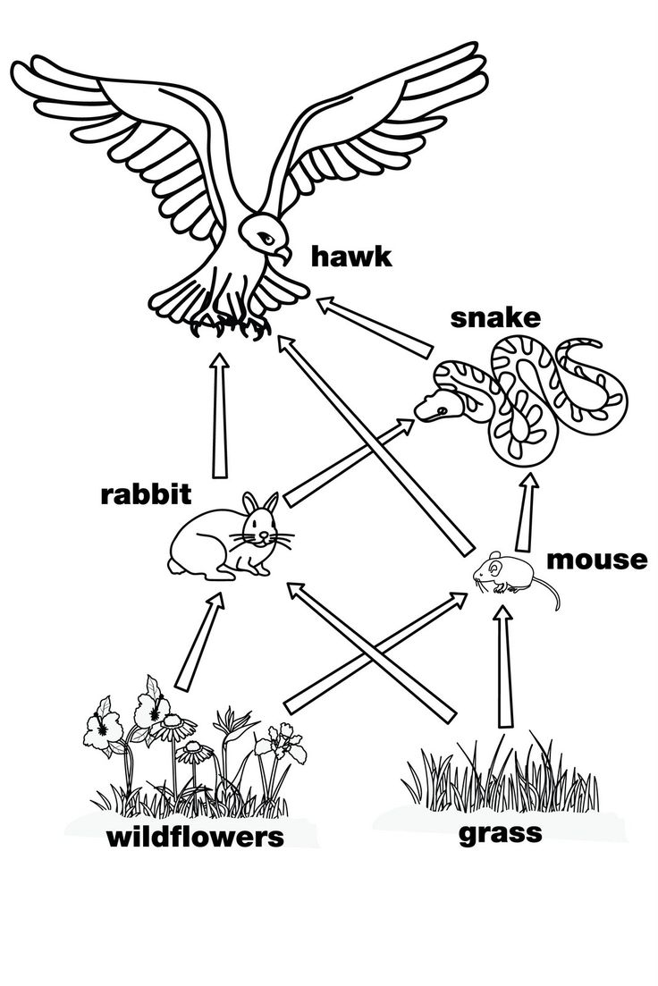
Unit evaluation page 20 parts 1 , 2 and 3 .
Food Pyramid is ...(Page 47 book)
Classify the foods into the food groups: corn, onion, banana, fish, yogurt, donut, cereal, canola oil, meat.
NOVEMBER 23
EVALUATION 2
Read pages 48-50-51-52-53 book.
Complete the chart
Cheese, juice, beans, lettuce, kiwi, olive oil, chicken, ice cream, rice.
Name of food | Grains | Veggies | Fruit | Milk | Meat and beans | oils

The digestive system Complete the information page 50 (listen)
*In your mouth, your teeth_____...
*When you …
*The___ mixes the pieces of granola bar…
*The _________from this soupy liquid pass..
*The parts of the food that your body…
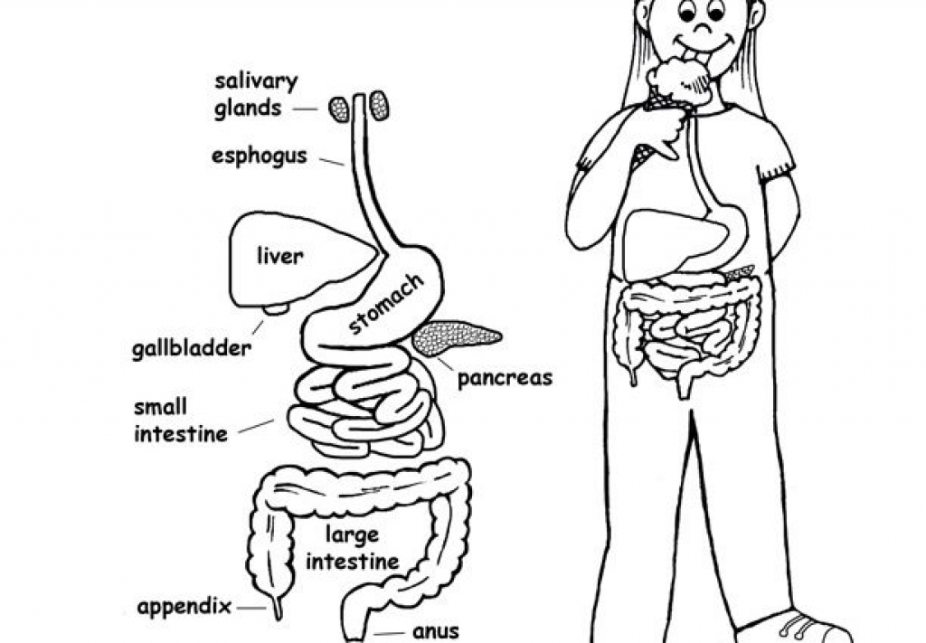
November 24
Read pages 54-55-56-58-59-72.
The human systems are: the mental map page 59
Physical Science

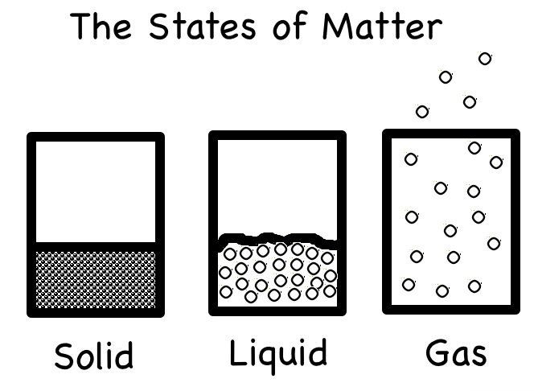

Definition matter, solid, liquid, gas.
Classify the object: air in the balloon, boy, pencil, river, water, cloud, ruler, helium, dog, oxygen.
Solid | Liquid | gas

Properties of matter (the mental map) page 72.

NOVEMBER 27
EVALUATION 3
Read pages 73, 74, 76, 77
Properties of matter
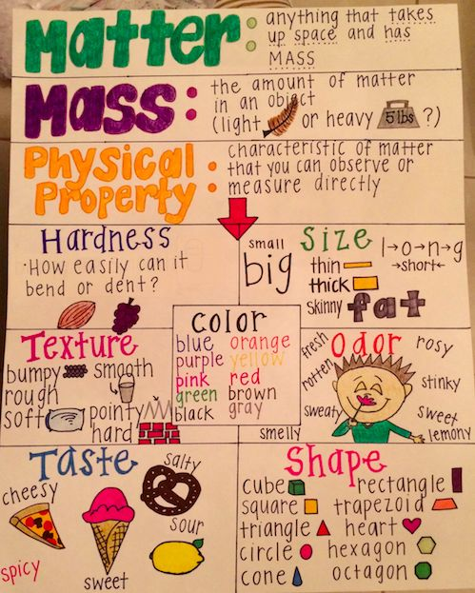
Classify the object according to the properties.
Flower, strawberry, butterfly, paper, house.

General properties of matter
Complete the information

*Mass is ----------
*Volumen is --------
*Temperature is----------
*A balance is--------
* A measuring cylinder is ------
*thermometer is------
*Energy is-------

The mental map page 76

NOVEMBER 28
Read pages 77-78-80
Different forms of energy
Activities 1, 2, 3 page 80

EARTH SCIENCE
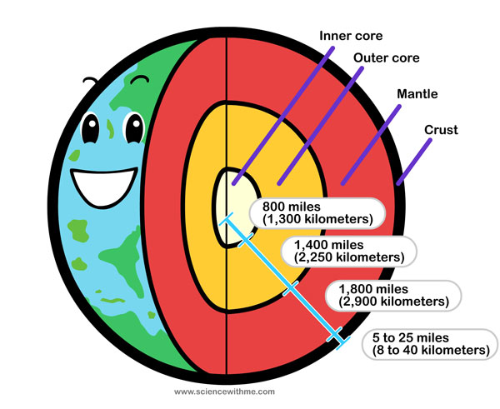

Read pages 98-99-100
Complete the chart
 | Definition | Characteristics | picture
Moon
Sun
Earth

NOVEMBER 29
EVALUATION 4
Read pages 102-103-104-107-108-109
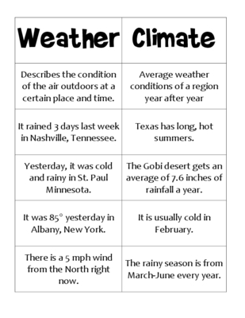
Complete and draw the atmosphere spheres.
The atmosphere is divided into five layers.

